Final Project
Marketing department organizational structure
Automatronics

Module 8 Assignment 1

By
Randy K. Pruitt

For – B6026
Dr. Castaneda
Date – 19 August 2011

Automatronics marketing department
Introduction
“The Pentagon building is composed of five concentric pentagonal rings connected by ten radial corridors (Global Security, n.d).” Hence the Pentagon’s structure forms the basis for the Automatronic’s marketing departments organizational structure with the use of concentric rings marked with a series of arrows aimed both outward across all the circles toward the consumers and inward across all the circles as consumer response. And like the ten radial connecting corridors of the Pentagon the arrows seen cutting across the marketing rings divide the circles into sectors of specialization.
The importance of marketing channels
“A marketing channel system is the particular set of marketing channels a firm employs, and decisions about it are among the most critical ones management faces (Keller & Kotler, 2009, p. 411).”
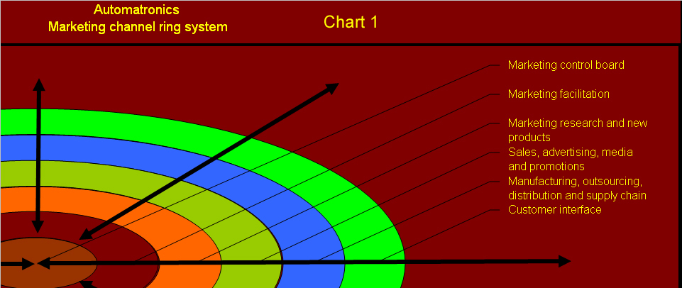
The above and below Chart 1 and Chart 2 derived from Keller & Kotler (2009, p. 629) on geographic organization defines the role of each color concentric ring system starting at the central position to the outer ring structure.
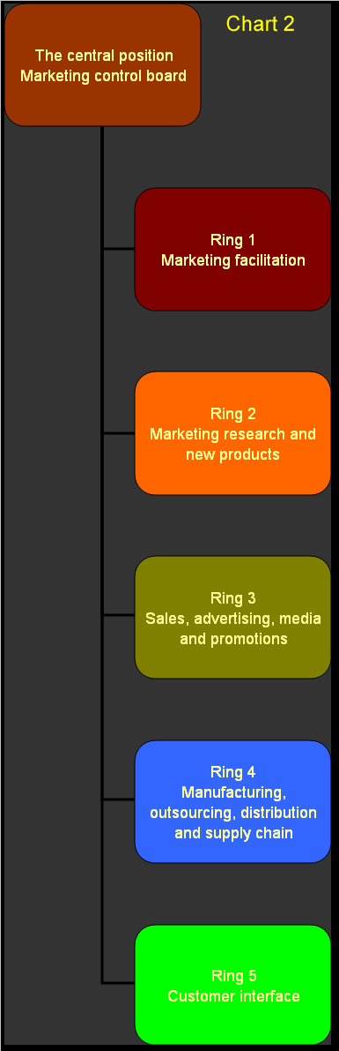
To the left, the flow chart matrix representation by color moving from the center from the top through the color rings outward as you move down the chart. At the top is the Marketing control board – where command and control decisions are made about product usage and issues involved.

Marketing facilitation – organizes marketing operations both outward and inward across the rings in accordance of the ring sector specialization, assesses budgeting and accounting measures.

Marketing research and new products – conducts the development, testing, demographic and safety analysis of product lines. Develops cost analysis.

Sales, advertising, media and promotions – conducts sales deployment and analysis, organization in advertising and media contact interface, sets up promotional campaigns for consumers and assigns pricing.

Manufacturing, outsourcing, distribution and supply chain – Sets up manufacturing distribution regional facilities, manages other outsource suppliers and distribution network.

Customer interface – direct customer contact for sales and feedback, depending on the ring sector this might be in the form of, direct sales, internet sales and kiosks, outlet stores or product interpretation.
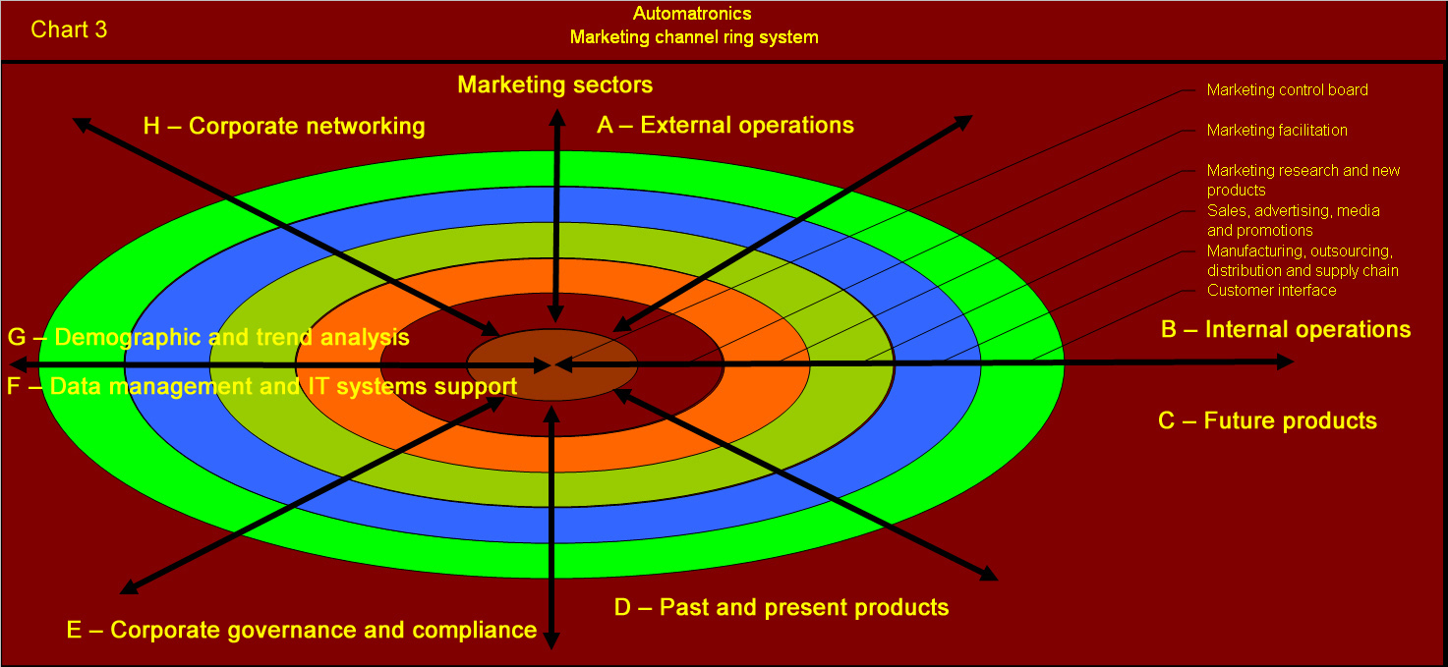
The above Chart 3 portrays marketing specialization sectors A through H moving clockwise around the marketing concentric ring system
- External operations – This is where transparency of external operations in product quality, consistency and supply are executed and monitored throughout the ring structure.
- Internal operations – this is where corporate standards and methods of operations training and education is overseen across the ring system.
- Future products – considers demographic trends in needed product changes and advances development toward new markets.
- Past and present products – assesses the usability, functionality, likes and dislikes of online products and looks for improvements.
- Corporate governance and compliance – from human resources, federal, state and municipal compliance, OSAH and other areas of compliance.
- Data management and IT systems support – handles from RFID communications, robotic operations, telemetry and communication systems, and IT operations across the company.
- Demographic and trend analysis – Here population needs and changes are assessed.
- Corporate networking – here public relations and interfacing with other entities for common needs purposes is carried out.

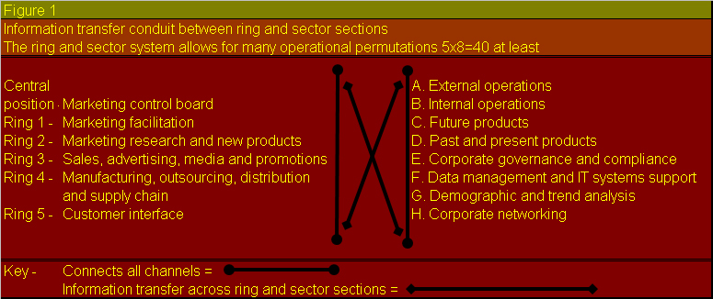
The above Figure 1 portrays the many operational possibilities that exist within and across Automatronics concentric marketing system allowing for a greater flow of elastic adaptability in adjusting to market changes.

References

Keller, K. L. & Kotler, P., (2009) Marketing management (13th ed) Pearson Prentice Hall, Retrieved June 30, 2011, from
http://digitalbookshelf.argosy.edu/#/books/0558503810/pages/15482633

Global Security (n.d) The pentagon, globalsecurity.org, Retrieved, August 17, 2011, from
http://www.globalsecurity.org/military/facility/pentagon.htm

